Opening Day
Pinehurst Greensomes
Saturday 28 March 2026
Prize Winners
Place | Pairing | Points
1 | R Rodger / A Kerr | 42
2 | R Binnie / A Stevenson | 41 BIH
3 | G Gibson / I Lindsay | 41
4 | W Chalmers / A Brown | 40 BIH

Closest to Pin  in Two Shots | 18th Hole  Andrew Hutchison
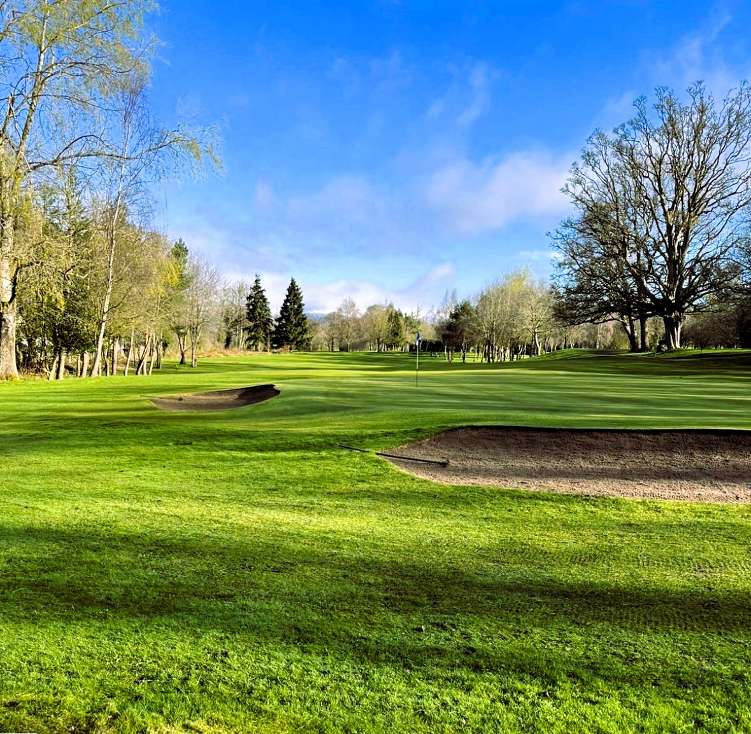
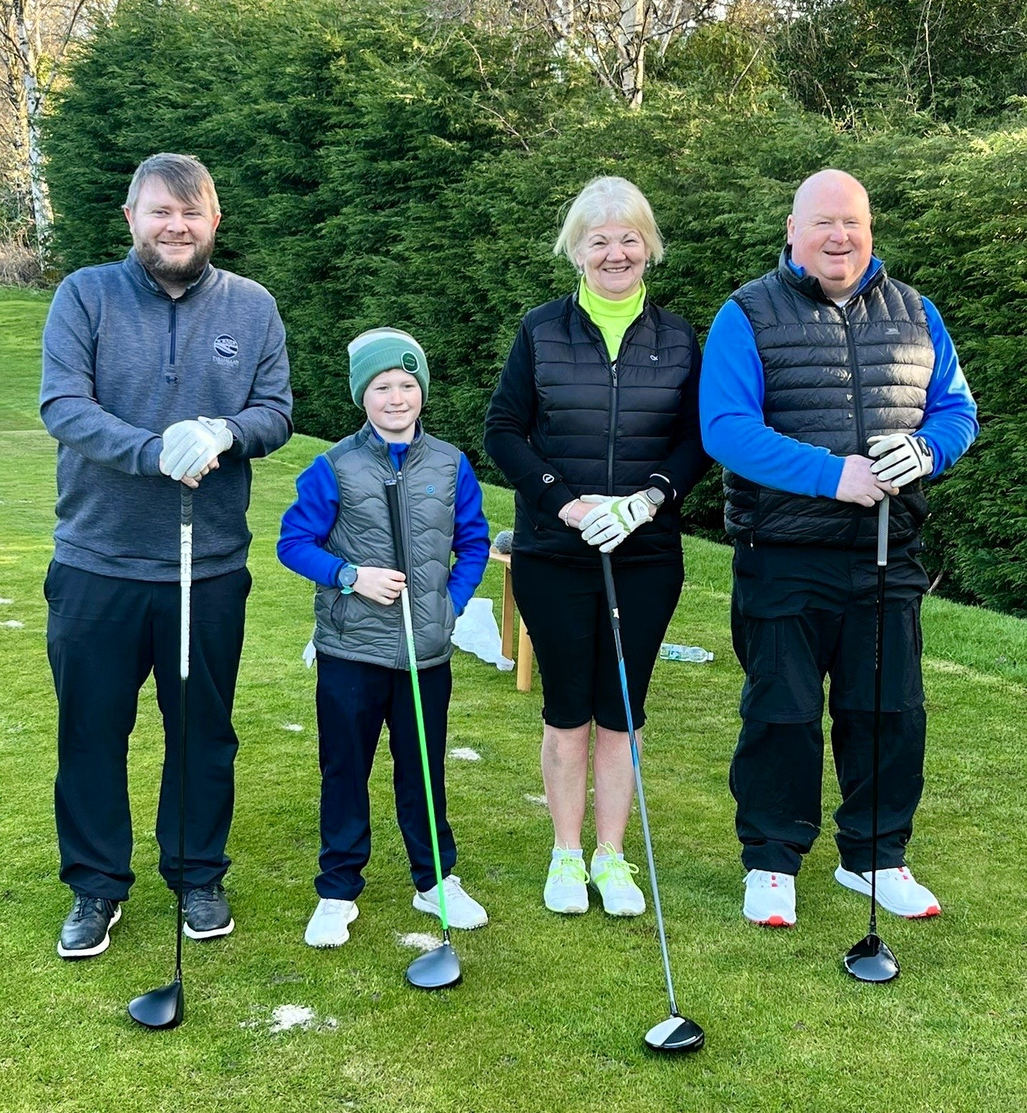
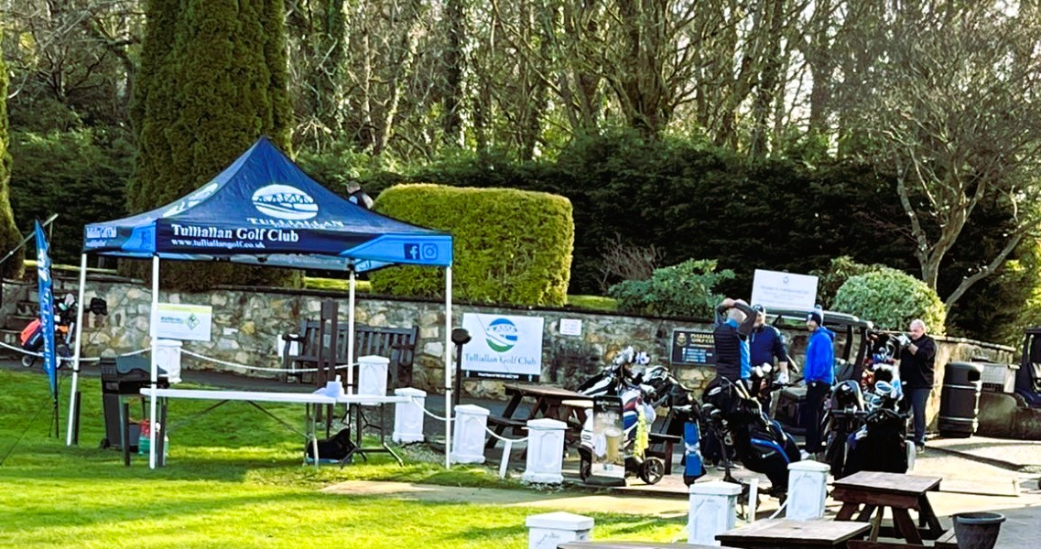

Tulliallan Golf Club

